Name

Mathematics Advanced Year 11
Trigonometry with
Acute Angles

Book 1 |  | Version: 261020  Feedback:  https://MrDingMaths.com
Contents
Syllabus Content 2
Learning Intention 3

Syllabus Content
MAV-11-04 applies trigonometry to solve problems involving geometric shapes
Trigonometry with acute angles
- Use Pythagoras’ theorem to find the exact sine, cosine and tangent ratios for angles of $30°$, $45°$ and $60°$
- Apply trigonometry to solve problems involving right-angled triangles in two dimensions, true and compass bearings, and angles of elevation and depression

Right-Angled Trigonometry

- The Trigonometric Ratios
- There are three trigonometric ratios: sine, cosine, and tangent, which compare the lengths of two sides of a triangle.
- The ratios specify an angle, as the opposite and adjacent sides depend on the angle.
- You can remember the three ratios using SOH CAH TOA
$$\sin{θ}=\frac{Opposite }{Hypotenuse}$$ | $$\cos{θ}=\frac{Adjacent }{Hypotenuse}$$ | $$\tan{θ}=\frac{Opposite}{Adjacent}$$

- Example Calculate unknown sides when angle is in sexagesimal form
Calculate the value of $x$. Round your answer to 2 decimal places
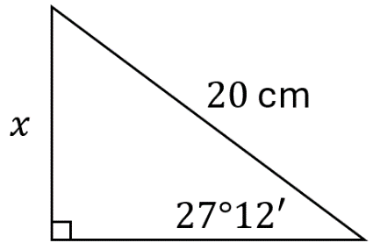  $$\sin{(27°{12}^{'})}=\frac{x}{20} \\ 20\sin{(27°{12}^{'})}=x \\ 9.14 cm=x$$ | 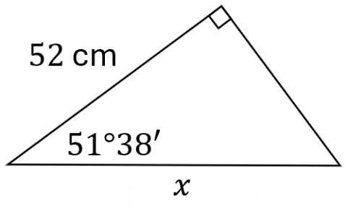  $$\cos{(51°{38}^{'})}=\frac{52}{x} \\ x\cos{(51°{38}^{'})}=52 \\ x=\frac{52}{\cos{(51°{38}^{'})}} \\ =84.78 cm$$

- Guided Practice
Calculate the value of $x$. Round to 2 decimal places.
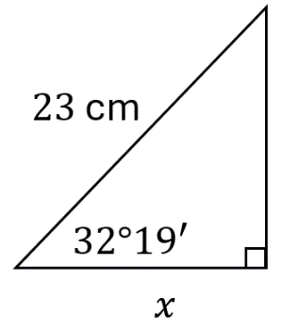  $19.44$ cm | 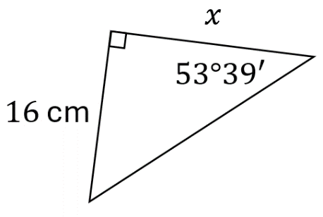  $x=11.77$ cm
- Example Calculate an unknown angle and round the result
Calculate the value of $θ$ and round to the nearest minute.
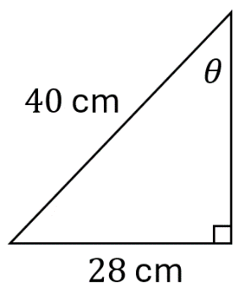
$\sin{θ=\frac{28}{40}}$
$θ=\sin^{-1}\left(\frac{28}{40}\right)$
$θ≈44.4270$
$≈44° {25}^{'}{ 37.21}^{''}$
$≈44° 26'$

- Guided Practice
Calculate the value of $θ$ and round to the nearest minute.
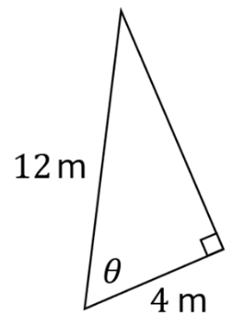  $$θ=70°32'$$ | 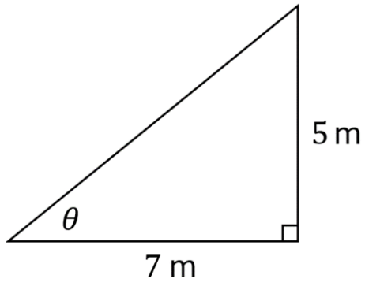  $$θ=35°32'$$

- Problem-solving using Trigonometry
- Identify the right-angled triangle.
- Label the unknown side or angle $x$ or $θ$, if it isn’t already.
- Solve for the unknown using trigonometry.

- Example Solve practical problems involving trigonometry
Find how high the ladder reaches up the wall.  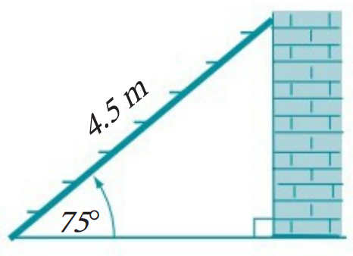  $$h$$  1. Triangle  2. Unknown $\left(h\right)$  3. Solve  $\sin{75°=}$ $\frac{h}{4.5}$  $4.5\sin{75°=h}$  $x≈4.35$ m | 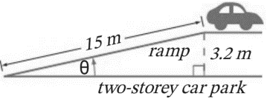  Find the angle of the ramp.  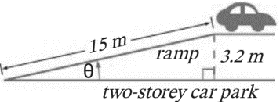  1. Triangle  2. Unknown $\left(θ\right)$  3. Solve  $\sin{θ}=$ $\frac{3.2}{15}$  $θ=\sin^{-1}\left(\frac{3.2}{15}\right)$  $θ≈12.32°$

- Guided Practice
- Determine the height of this tree.  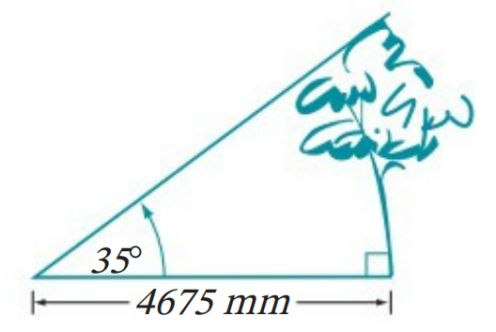  $x=3273.47$ mm | - Find the angle between the kite and the ground.  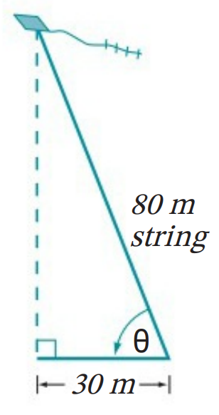  $$θ=67.98°$$

- Angles of Elevation and Depression
- Line of sight is a straight line from your eye to an object.
- Angle of elevation: The angle you turn to look up from the horizontal.
- Angle of depression: The angle you turn to look down from the horizontal.
- The horizontal is a line parallel to the ground.
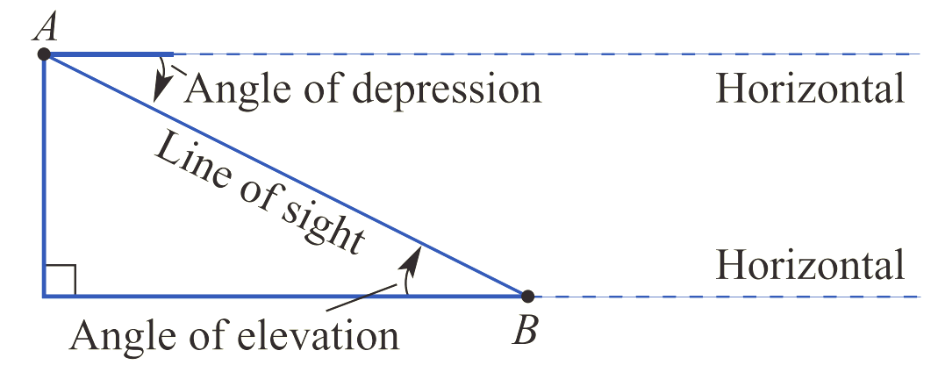

- Identify angles of elevation and depression
Identify whether the angle shown is an angle of elevation, depression, or neither.
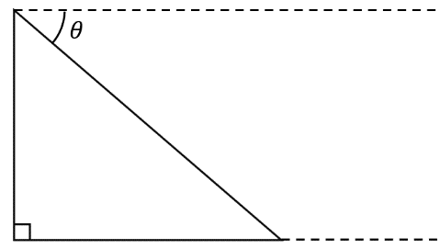
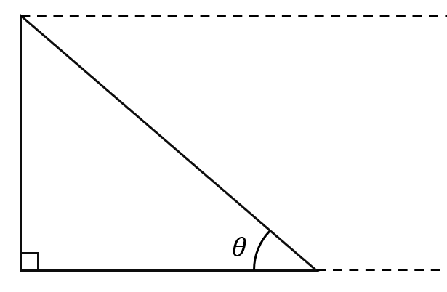
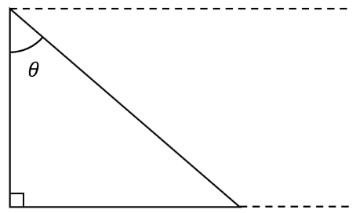
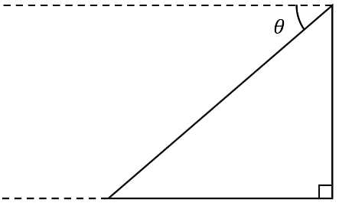 | 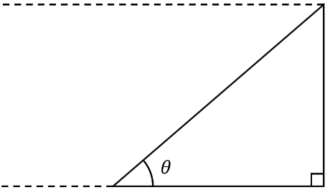 | 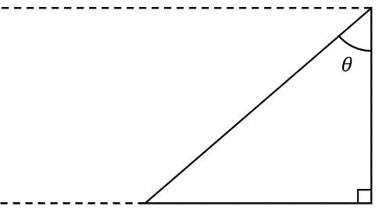
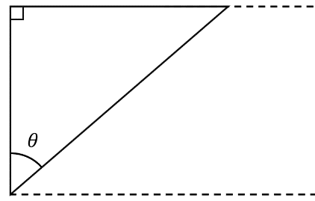 |  | 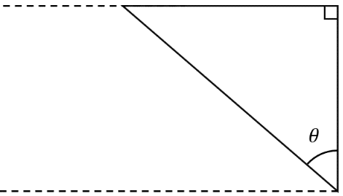  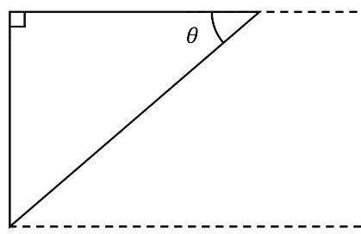

- Finding Angles of Elevation and Depression
- To find angles, we can use these angle relationships:
  - Angles in a right-angle sum to $90°$
  - Angle sum of a triangle is $180°$
  - Alternate angles on parallel lines are equal.

- Example Calculate angles of elevation and depression
Calculate the angle of elevation.  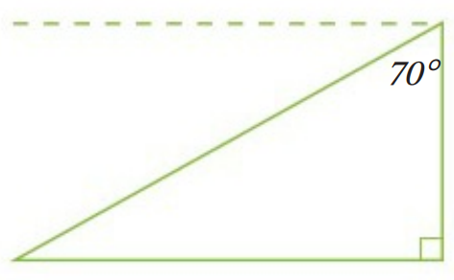  $$θ$$  $$θ+70°+90°=180° (angle sum of a triangle) \\ θ+160°=180° \\ θ=20°$$ | Calculate the angle of depression.  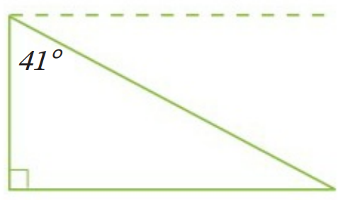  $$θ$$  $$θ+41°=90° (angles in a right angle) \\ θ=90°-41° \\ θ=49°$$

- Guided Practice
- Calculate the angle of elevation.  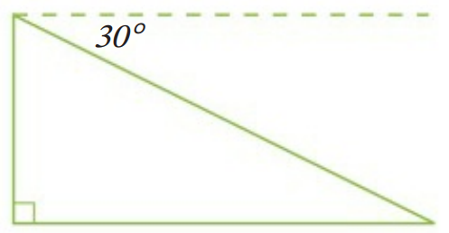  $$30°$$ | 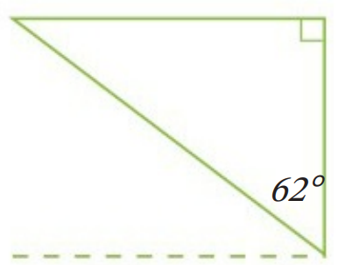  - Calculate the angle of depression.  $$28°$$
- Calculate the angle of elevation.  $$54°$$ | 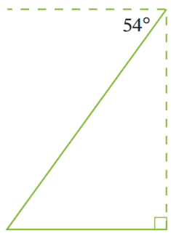  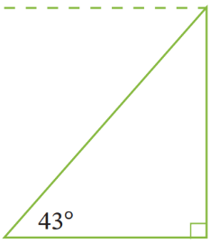  - Calculate the angle of depression.  $$43°$$

- Example Solve problems involving angles of elevation and depression
Worked Example | Your Turn
A kite is flying at a height of 45 m above the ground at the end of a string of length 70 m. Find the angle of elevation from the ground to the string.  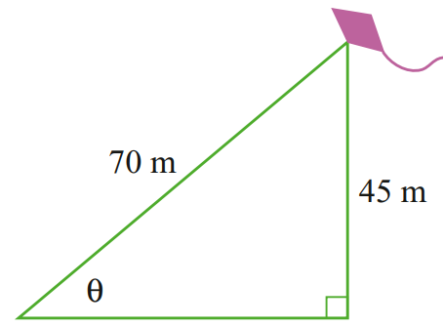  $$\sin{θ}=\frac{45}{70}$$  $θ=\sin^{-1}\left(\frac{45}{70}\right)$  $θ≈40°$ | A kite is flying at a height of 35 m above the ground at the end of a string of length 60 m. Find the angle of elevation from the ground to the string, answer to the nearest minute.  $$35°41'$$
The angle of elevation of the top of a flagpole from the ground, as observed from a point 15 m from its base, is 63°.  Find the height of the flagpole.  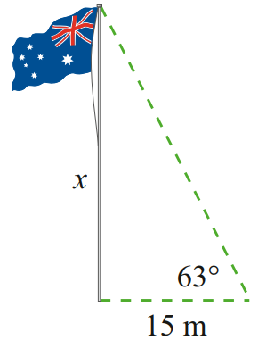  $\tan{(63°)}=$ $\frac{x}{15}$  $15\tan{(63°)}=x$  $x≈29.4 m$ | The angle of elevation of the top of a flagpole from the ground, as observed 50 m from its base, is 38°.  Find the height of the flagpole to 1 d.p.  $39.1$ m
The angle of depression from the top of a vertical cliff, 150 m above sea level, to a boat below is 50°. Find the distance of the boat from the base of the cliff to the nearest metre.  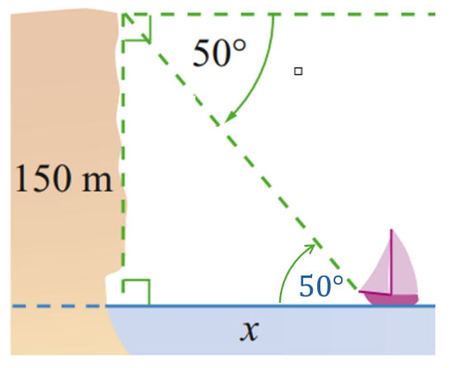  $\tan{(50°)}=$ $\frac{150}{x}$  $x=\frac{150}{\tan\left(50°\right)}$  $x≈126 m$ | The angle of depression from the top of a vertical cliff, 135 m above sea level, to a boat below is 37°. Find the distance of the boat from the base of the cliff to the nearest metre.  179 m

Bearings and Trigonometry

- True Bearings
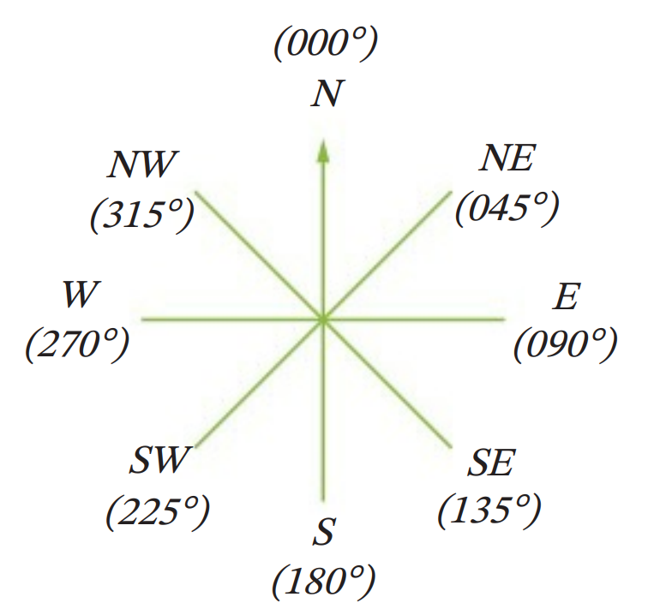
- Bearings: https://www.geogebra.org/m/er3jqacn
- Bearings give a travel direction from one point to another.
- With bearings, we are always taking a top-down view.

- True bearing measures the angle to turn clockwise from north.
- True bearings always use three digits.
If a navigator only hears two digits, then they know they need it to be repeated.

- Example Sketch true bearings
The bearing of A from O is 060$°$ | 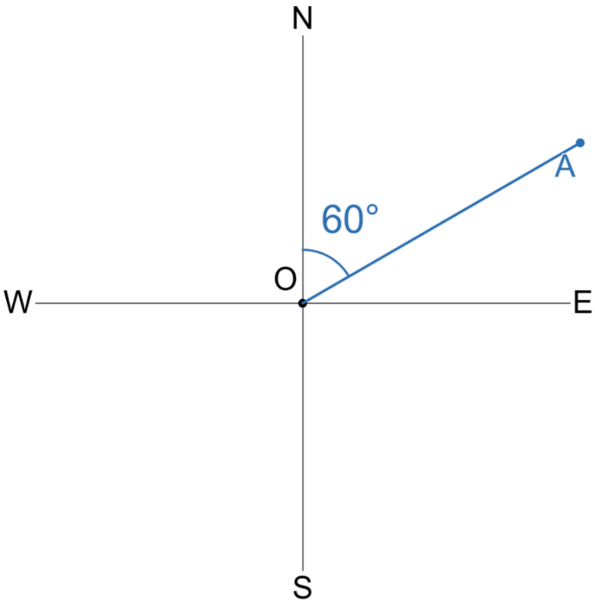  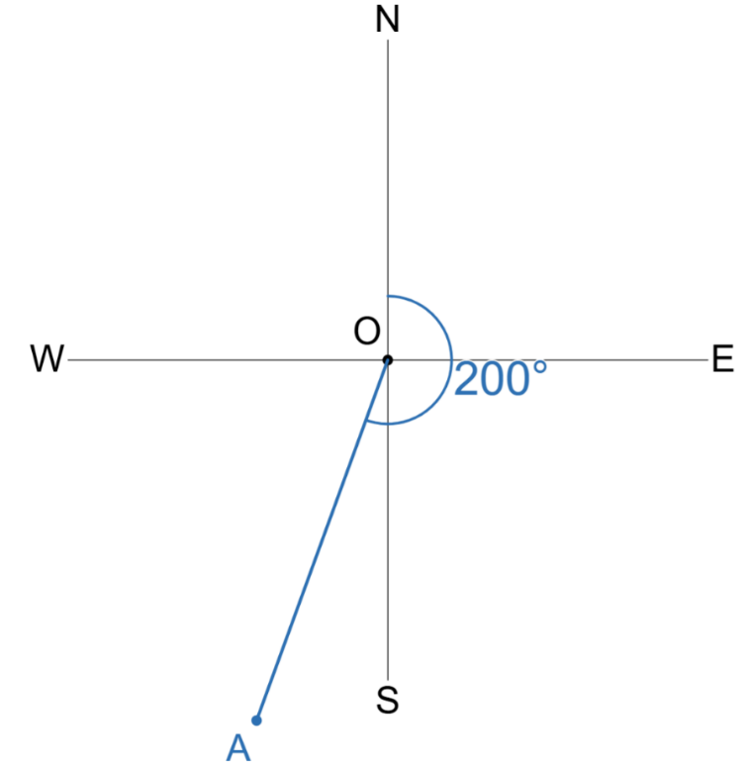  The bearing of A from O is 200$°$

- Guided Practice
Sketch these true bearings of A from O.
- $225°$  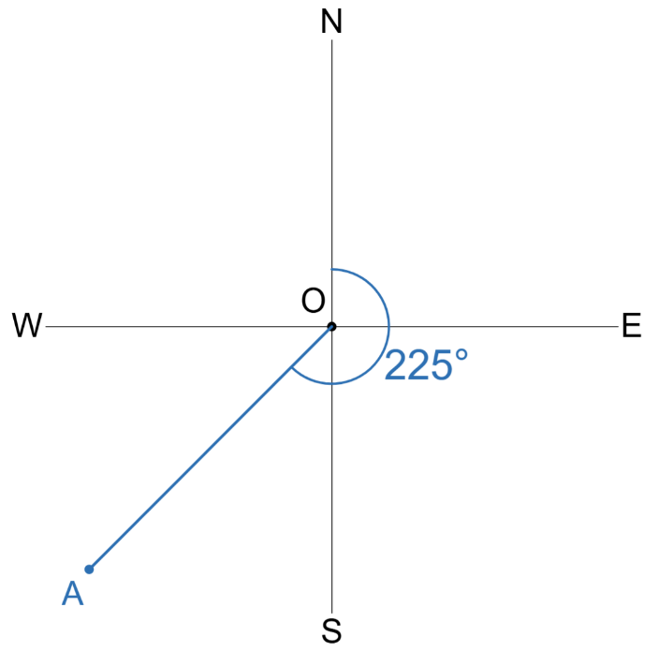  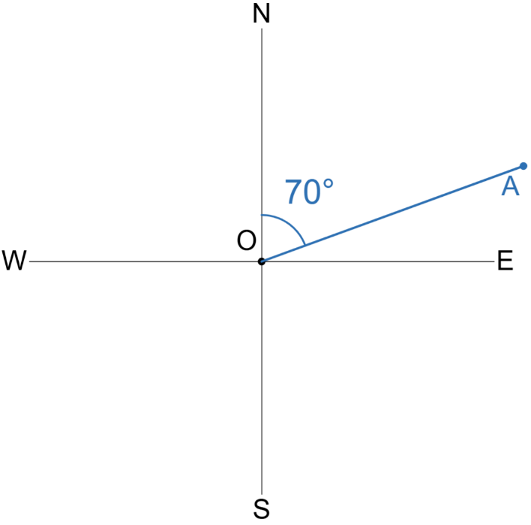  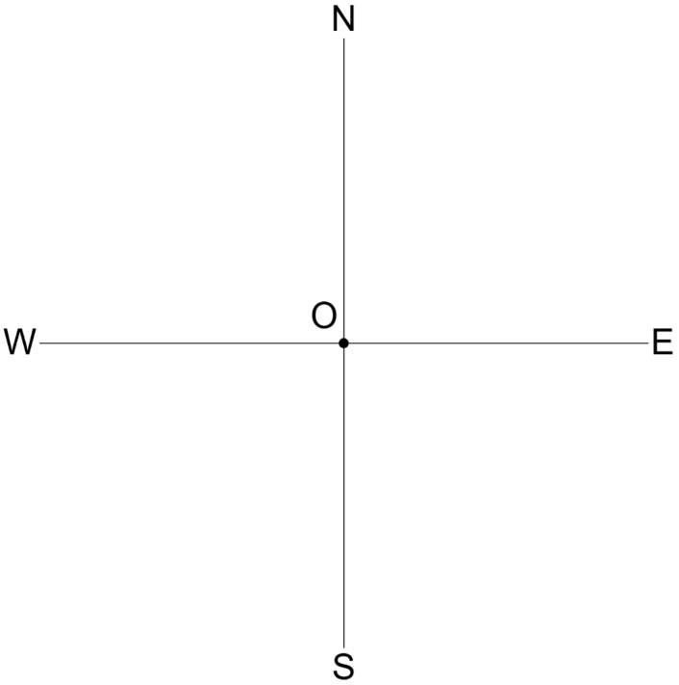 | - $070°$ |  | - $330°$  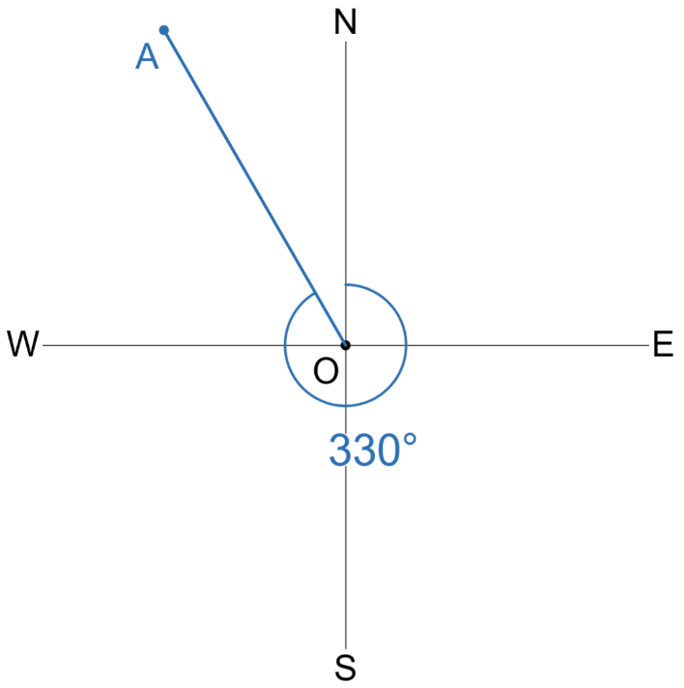
- Example Interpret true bearings
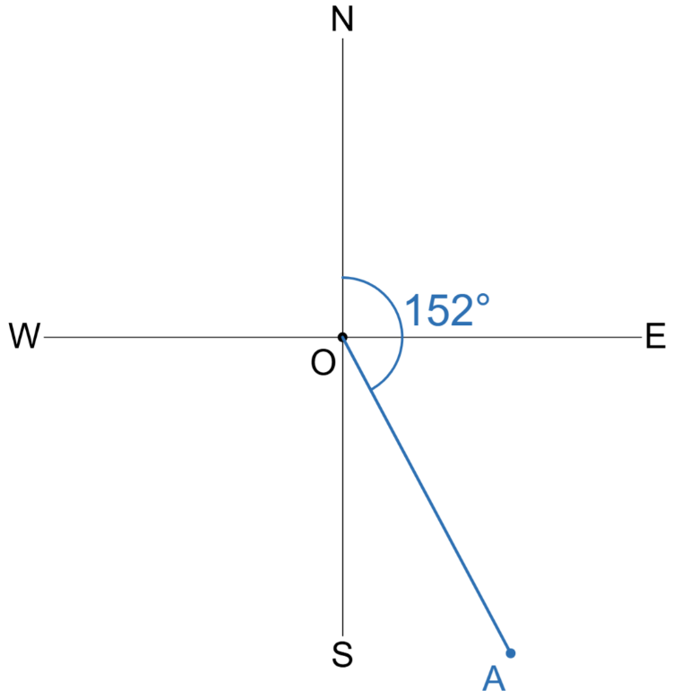  Write the true bearing of A from O  $152°$ |  | 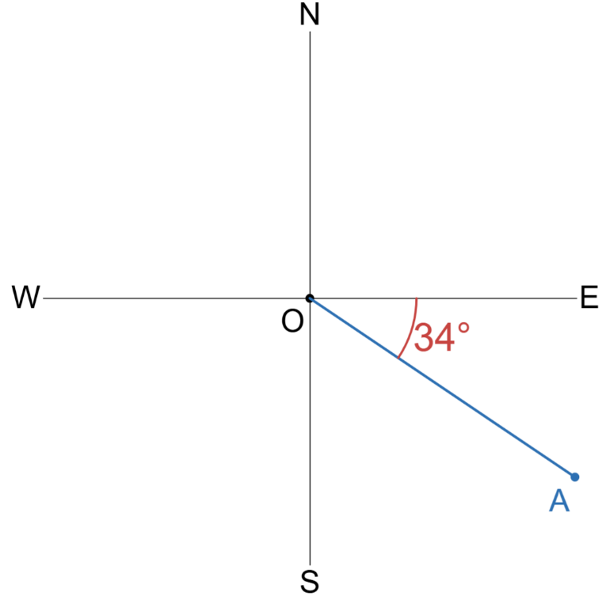  Write the true bearing of A from O  $90°+34°$  $=124°$

- Guided Practice
Write the true bearing of $A$ from $O$
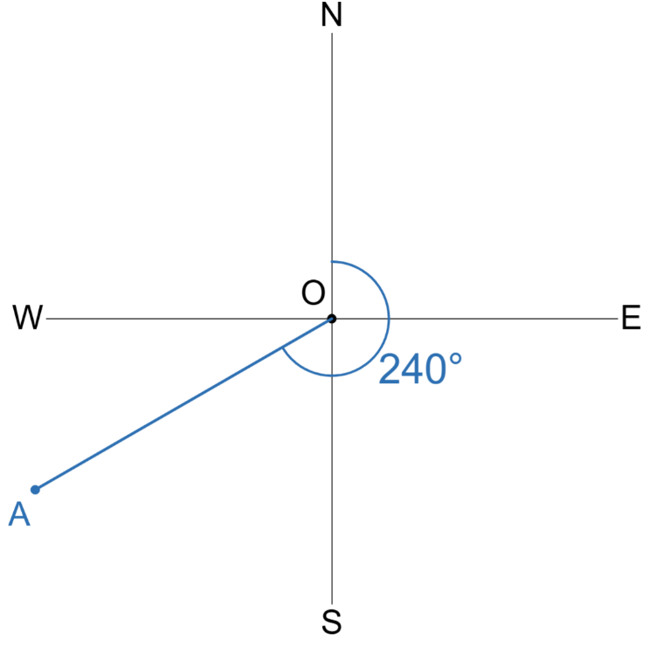  $$240°$$ | 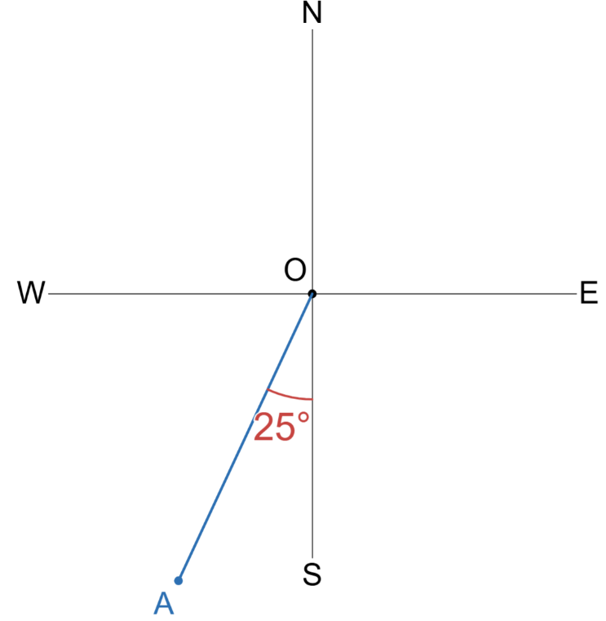  $$205°$$ | 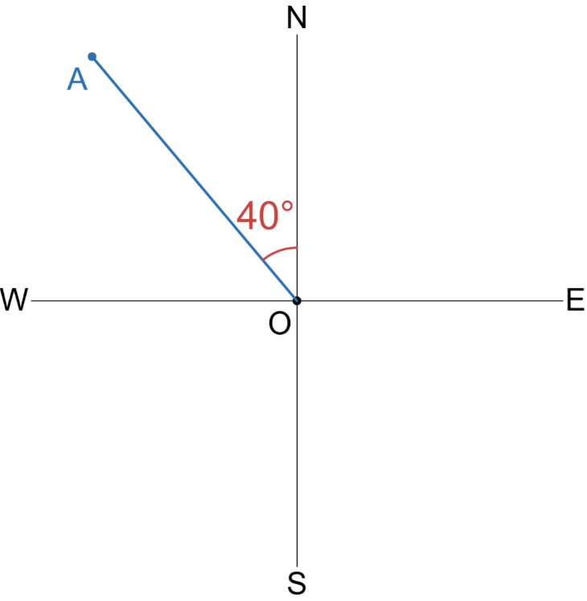  $$320°$$

- Compass Bearings
Compass bearings tell you an acute angle to turn, starting from North or South.
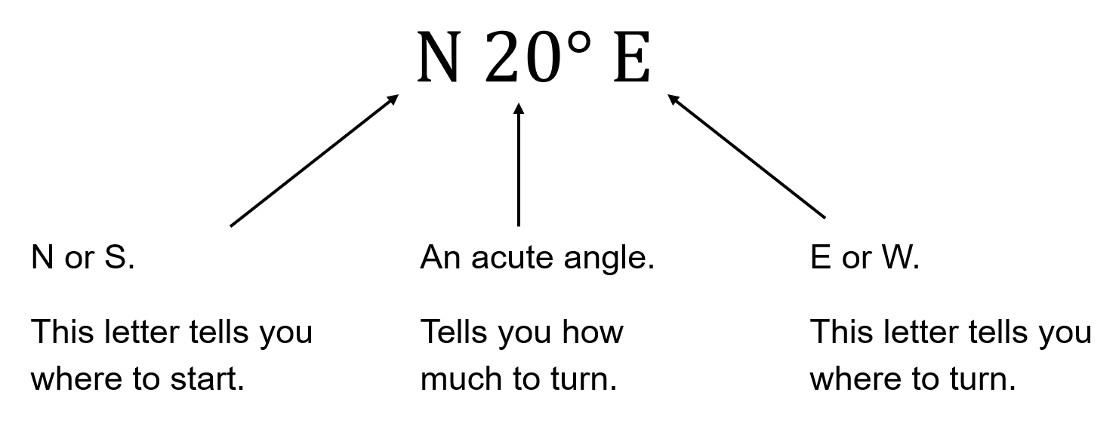

- Example Sketch a compass bearing
The bearing of A from O is $N60°W$ | 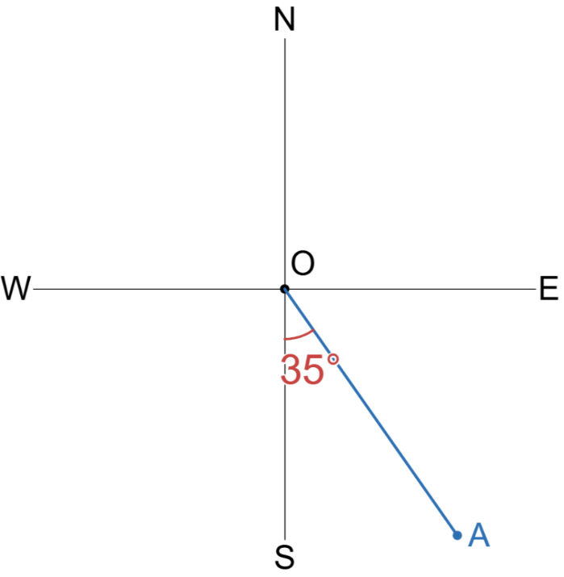  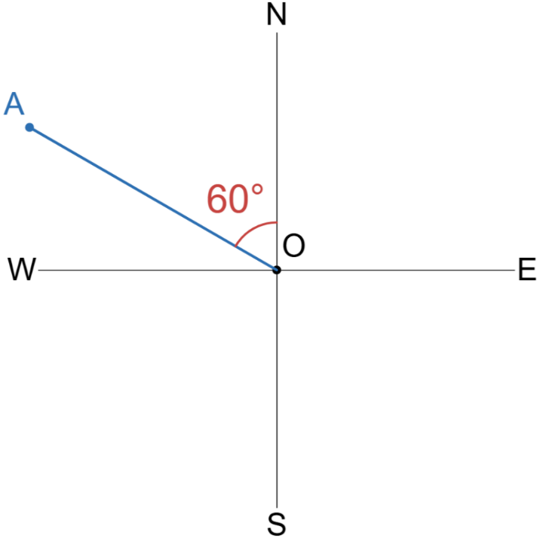  The bearing of A from O is $S35°E$

- Guided Practice
Sketch these compass bearings of A from O.
- $N75°W$  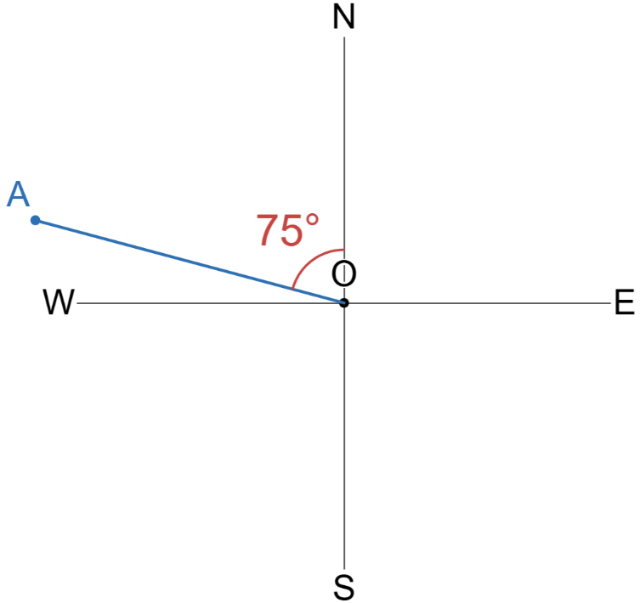  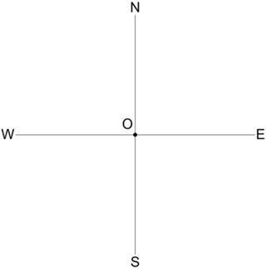 | - $S55°E$  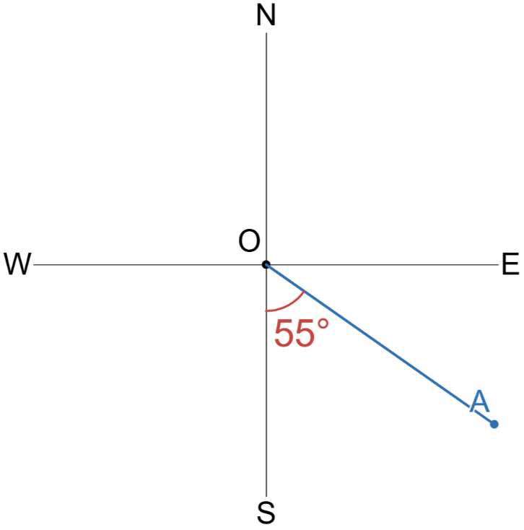 | - $S80°W$  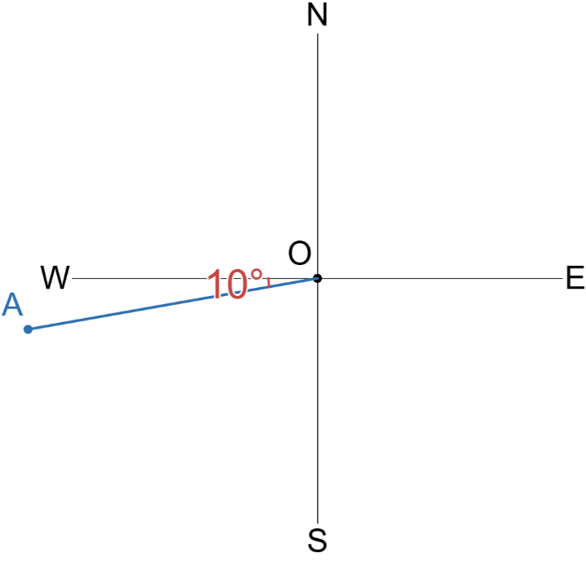

- Bearing Between Two Locations
- “From” shows where you start a bearing.
- Bearing of “B from A” means: stand at A, find direction to B.
- In navigation, we use true bearing; compass bearings are rare.
- Bearings: https://www.geogebra.org/m/rpvgcshx
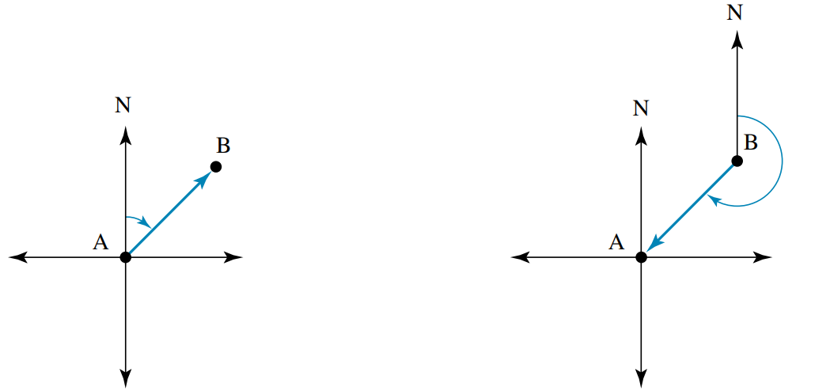  B from A | A from B
- Identify on your diagram the angle you are trying to find.
- Find the angle using angle relationships.

- Example Determine the bearing between two locations
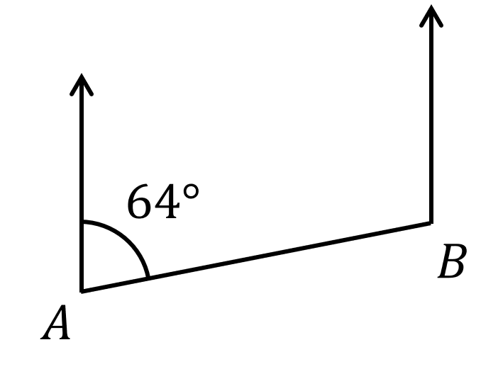
What is the bearing of $A$ from $B$?

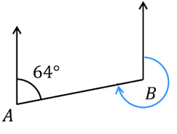  1. Identify angle | 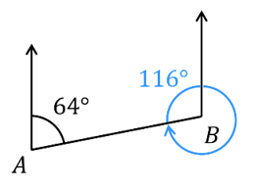  2.  Cointerior angles | 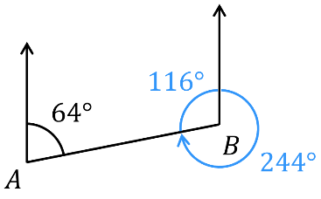  Angles at a point
The bearing of $A$ from $B$ is 244$°$

- Guided Practice
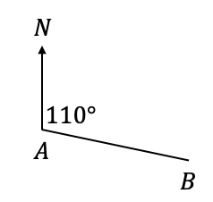
Determine the true bearing of
- $A$ from $B$  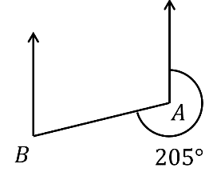  025° | - $A$ from $B$  255°
- $A$ from $B$  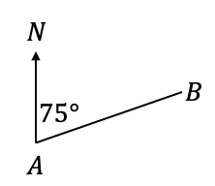  255° | - $A$ from $B$  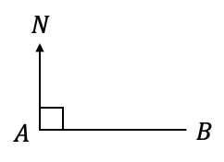  270°
- $O$ from $A$  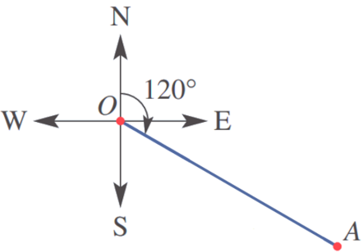  300° | - $O$ from $A$  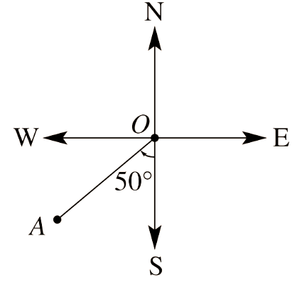  050°

- Problems involving Bearings and Trigonometry
- Draw a diagram and a compass rose at each point.
Label all known information (known angles, distances, what you are trying to find).
- Draw an appropriate right-angled triangle.
- Find the unknown using trigonometry

- Example Solve problems involving bearings and trigonometry
A bushwalker walks 3 km on a bearing of 060$°$ from point A to point B.
Find how far east (correct to 1 decimal place) point B is from point A.
Step 1: Diagram  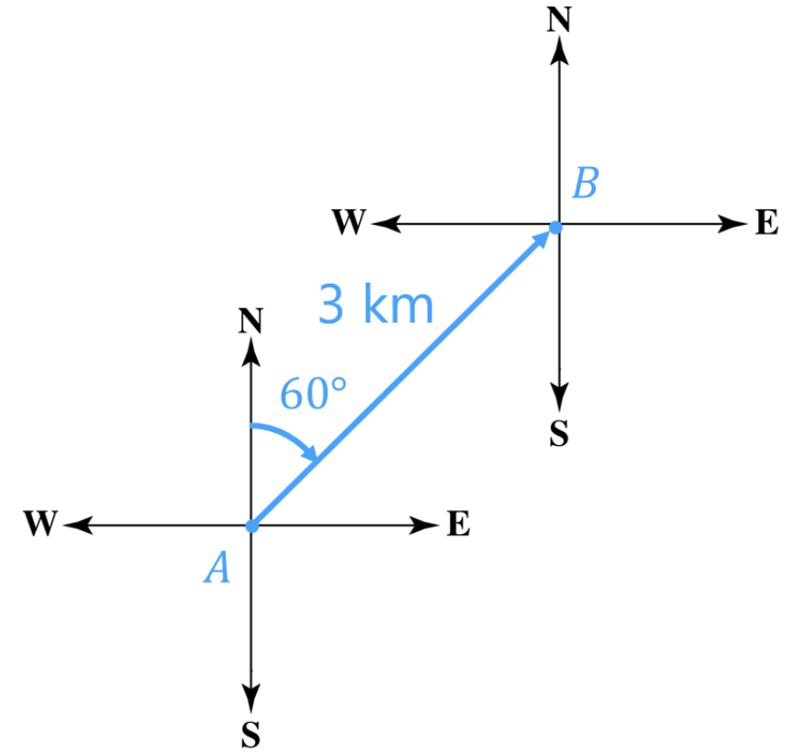 | 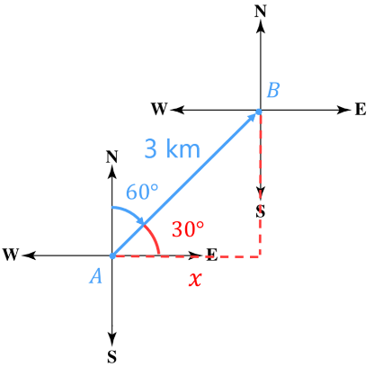  Step 2: Triangle | Step 3: Solve  $\cos\left(30°\right)=$ $\frac{x}{3}$  $3\cos\left(30°\right)=x$  $2.6 km=x$  The bushwalker is 3 km east of where they started.

- Guided Practice
- A fishing boat starts from point $O$ and sails 75 km on a bearing of 160° to point $B$.
How far east of its starting point is the boat, to the nearest kilometre?
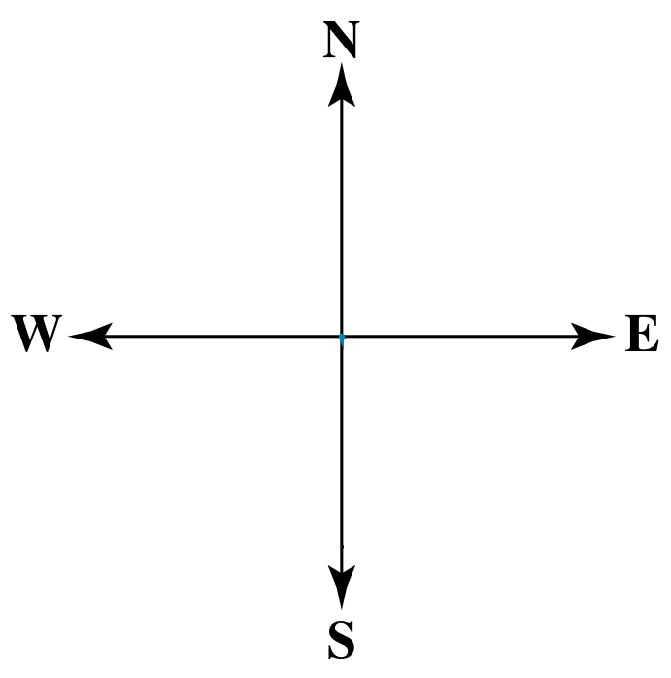

26 km
- An athlete runs 10 km on a bearing of 200° from the start to the finish line.
How far south does the triathlete run? Answer to the nearest kilometre.

9 km

Sine Rule

- Sine Rule (Finding a Side)
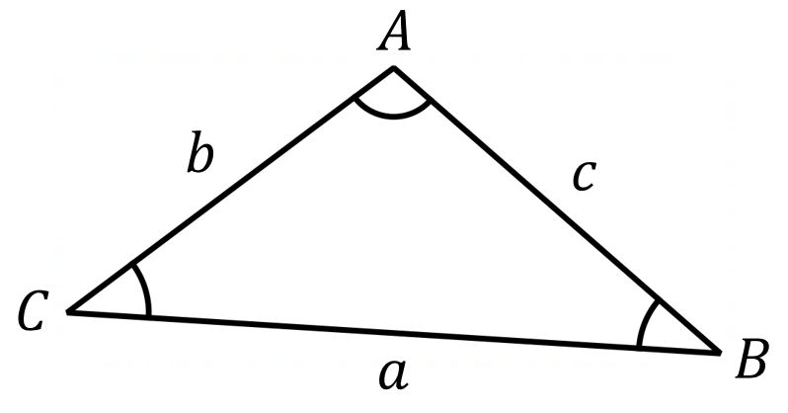

$$\frac{a}{\sin{A}}=\frac{b}{\sin{B}}=\frac{c}{\sin{C}}$$

- Write sine rule equation from a diagram
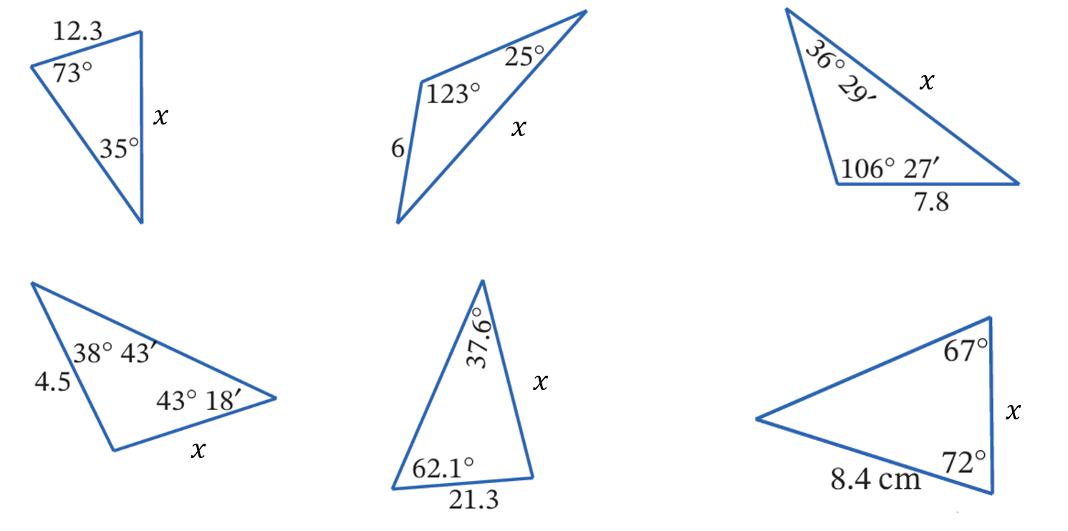

$$\frac{x}{\sin{73°}}=\frac{12.3}{\sin{35°}}$$

- Sine Rule (Finding a Side)
$$\frac{a}{\sin{A}}=\frac{b}{\sin{B}}=\frac{c}{\sin{C}}$$

- Example Calculate a side length using sine rule
Find the length of the missing side, to 1 d.p.
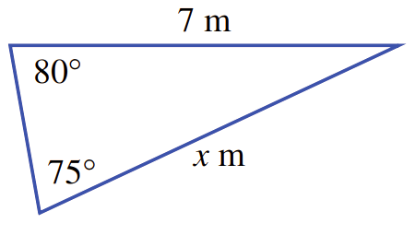
$$\frac{x}{\sin{80°}}=\frac{7}{\sin{75°}} \\ ×\sin{80°}=×\sin{80°} \\ x=\frac{7\sin{80°}}{\sin{75°}} \\ ≈7.1 m$$

- Guided Practice
Find the length of the missing side, to 1 d.p.
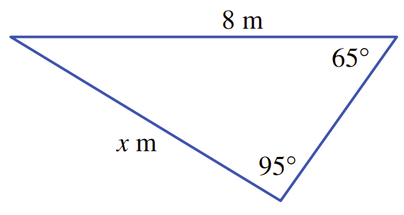  7.3 m | 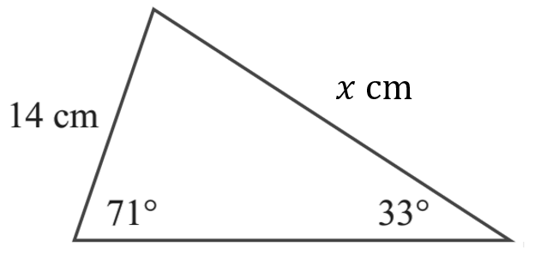  24.3 cm

- Sine Rule (Finding an Angle)
When finding an angle, have sin in the numerator.
This makes it easier to solve for an angle.

$$\frac{\sin{A}}{a}=\frac{\sin{B}}{b}=\frac{\sin{C}}{c}$$

- Example Calculate an angle using sine rule
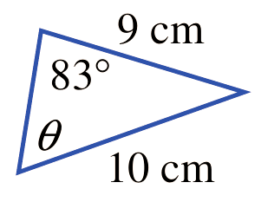
Find the missing angle to the nearest minute.
$$\frac{\sin{θ}}{9}=\frac{\sin{83°}}{10} \\ ×9=×9 \\ \sin{θ}=\frac{9\sin{83°}}{10} \\ θ=\sin^{-1}\left(\frac{9\sin{83°}}{10}\right) \\ ≈63°17'$$

- Guided Practice
Find the missing angle to the nearest minute.
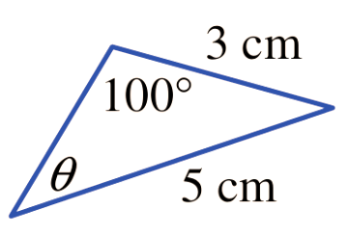  36° 13’ | 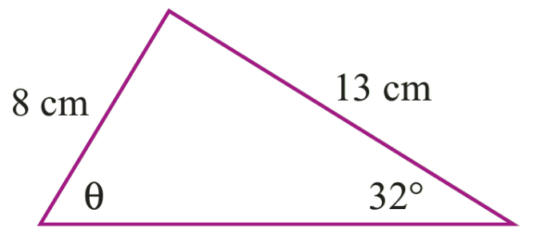  59° 27’
- Sine Rule (Finding an Obtuse Angle)
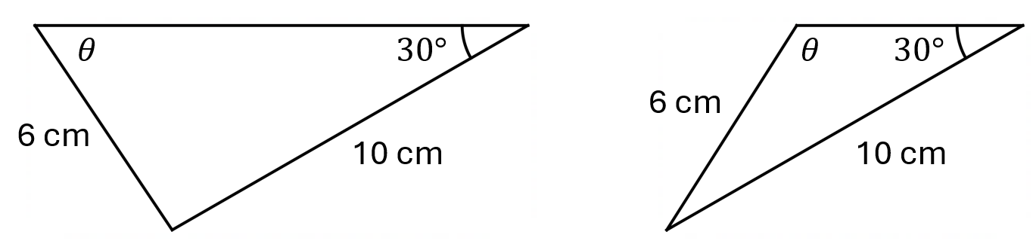
Given two sides and one angle, it is sometimes possible to make 2 triangles:

This is due to the identity: $\sin{θ}=\sin{(180°-θ)}$
The calculator will always give the acute angle when using $\sin^{-1}{( )}$
To get the obtuse angle, subtract the result from 180: $180°-θ$
You will learn the reason for this if you study Mathematics Advanced

- Example Calculate an angle using sine rule
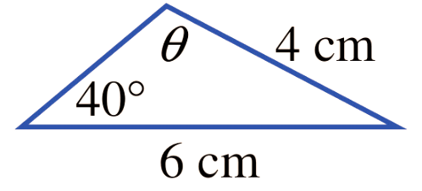
Find the missing angle to the nearest degree, given it is obtuse.
$$\frac{\sin{θ}}{6}=\frac{\sin{40°}}{4} \\ ×6=×6 \\ \sin{θ}=\frac{6\sin{40°}}{4} \\ θ=\sin^{-1}\left(\frac{6\sin{40°}}{4}\right) \\ ≈75° \\ ∴θ=180°-75°=105°$$

- Guided Practice
Find the missing angle to the nearest degree, given it is obtuse.
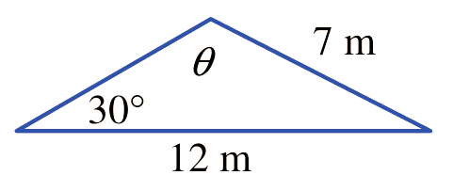  121° | 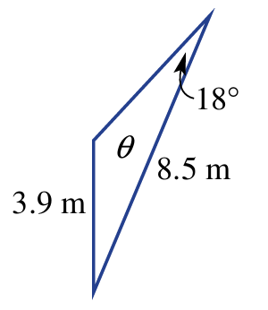  138°

Cosine Rule

- Cosine Rule (Finding a Side)

$$c^{2}=a^{2}+b^{2}-2ab\cos{C}$$

- Write Cosine rule equation from a diagram
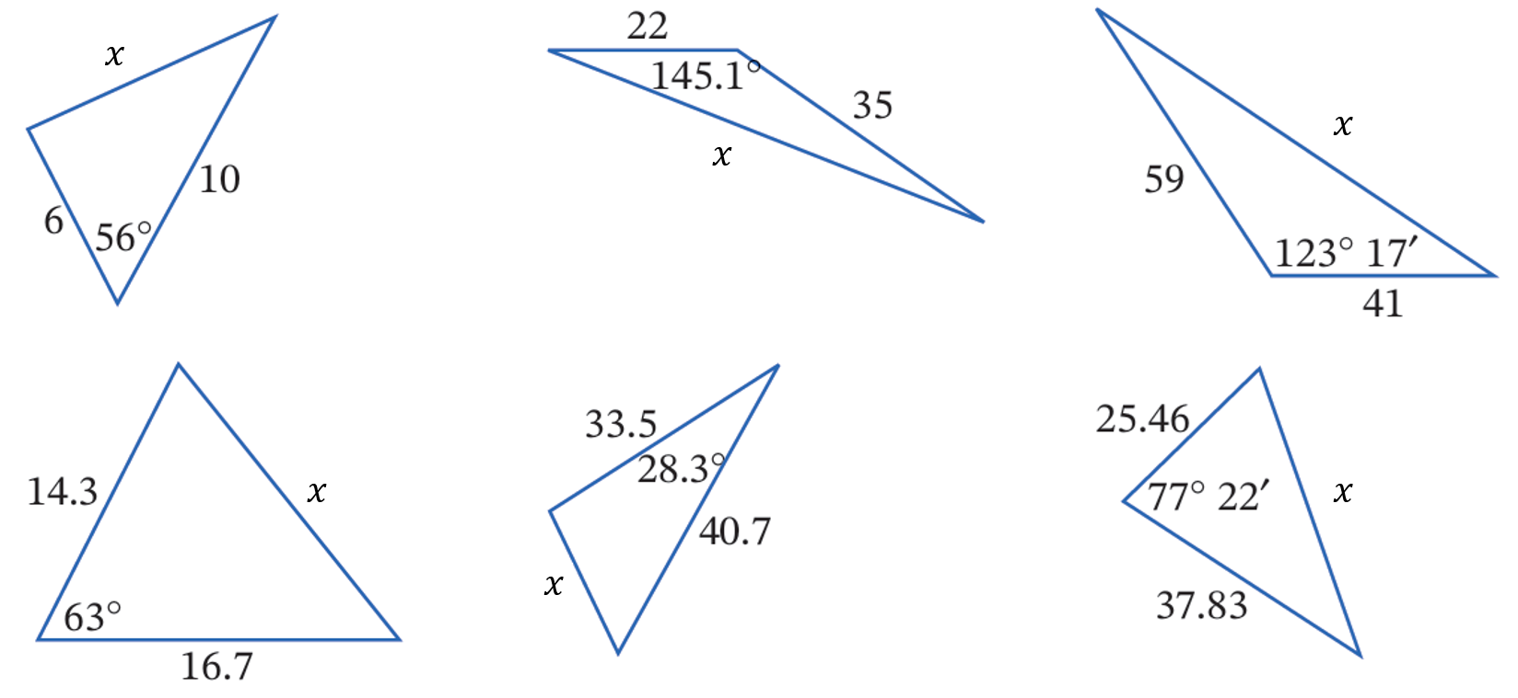

$$x^{2}=6^{2}+{10}^{2}-2\left(6\right)\left(10\right)\cos{56°}$$

- Cosine Rule (Finding a Side)

$$c^{2}=a^{2}+b^{2}-2ab\cos{C}$$

- Example Calculate a side using cosine rule
Calculate the length of $x$ to 2 d.p.
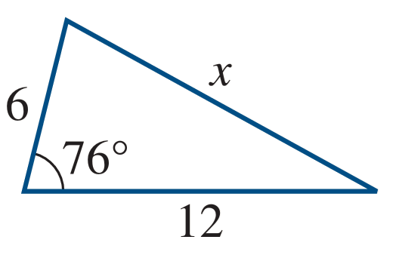
$$c^{2}=a^{2}+b^{2}-2ab\cos{C} \\ x^{2}=6^{2}+{12}^{2}-2\left(6\right)\left(12\right)\cos{76°} \\ x=\sqrt{6^{2}+{12}^{2}-2\left(6\right)\left(12\right)\cos{76°}} \\ ≈12.05$$

- Guided Practice
Calculate the length of $x$ to 2 d.p.
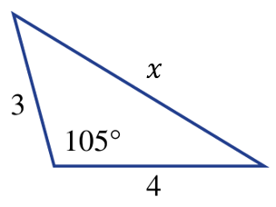  5.59 | 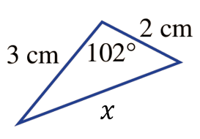  3.94

- Cosine Rule (Finding an Angle)
$c$ is always the side OPPOSITE the angle you want to find.
The other two sides are $a$ and $b$ (order doesn't matter).
$$\cos{C}=\frac{a^{2}+b^{2}-c^{2}}{2ab}$$

- Write Cosine rule equation from a diagram
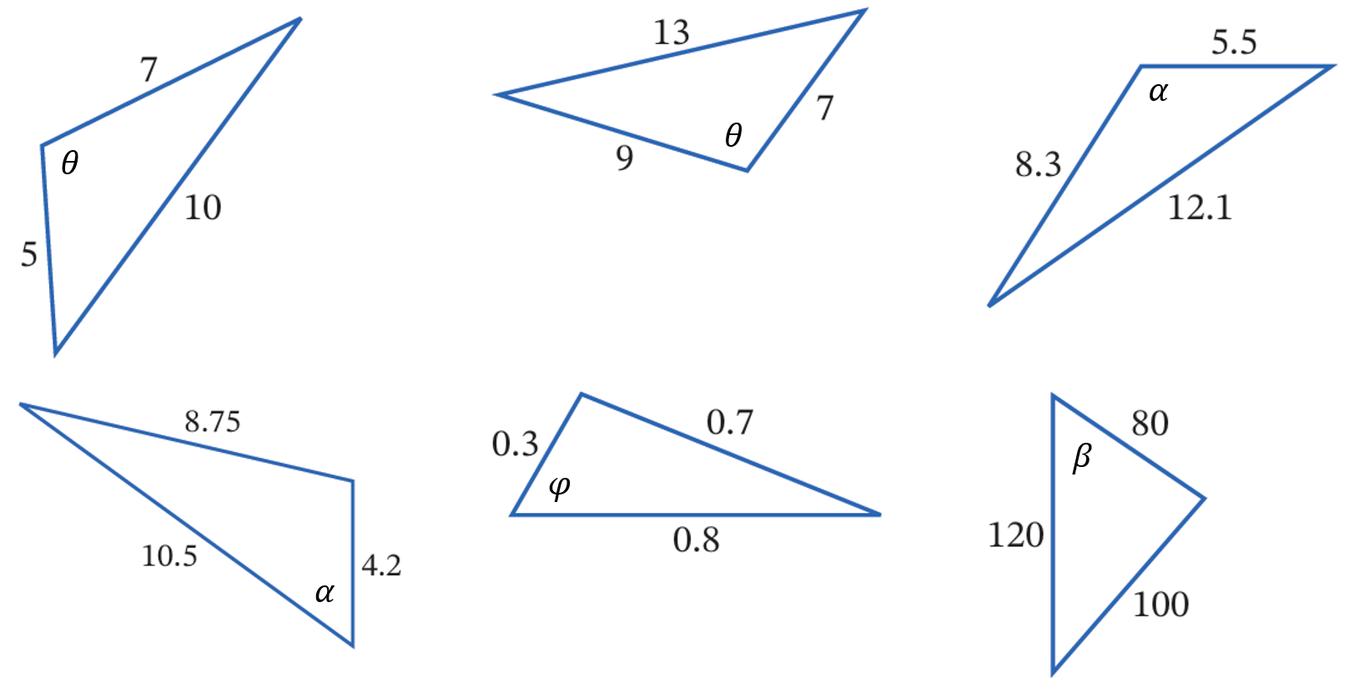

$$\cos{θ}=\frac{5^{2}+7^{2}-{10}^{2}}{2\left(5\right)\left(7\right)}$$

- Cosine Rule (Finding an Angle)

$$\cos{C}=\frac{a^{2}+b^{2}-c^{2}}{2ab}$$

- Example Calculate an angle using cosine rule
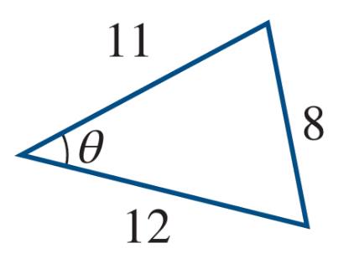
Calculate $θ$ to the nearest minute.
$$\cos{θ}=\frac{{11}^{2}+{12}^{2}-8^{2}}{2\left(11\right)\left(12\right)} \\ θ=\cos^{-1}\left(\frac{{11}^{2}+{12}^{2}-8^{2}}{2\left(11\right)\left(12\right)}\right) \\ θ=40°25'$$

- Guided Practice
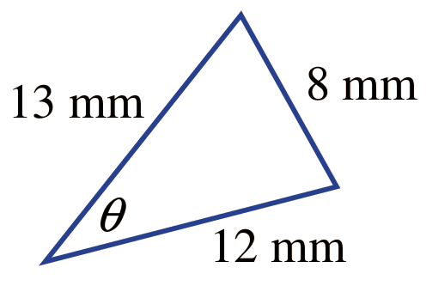  $$37° 3'$$ | 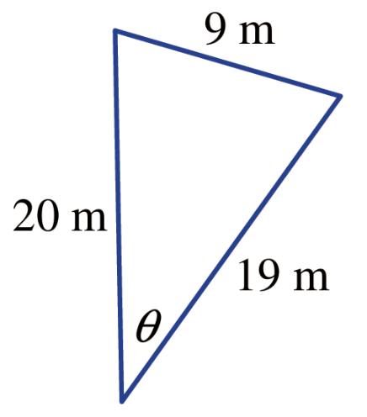  $$26° 32'$$

Area of a Triangle

- SAS Area Rule
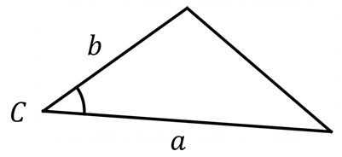

$$A=\frac{1}{2}ab\sin{C}$$

- Example Calculate area of a triangle using SAS area rule
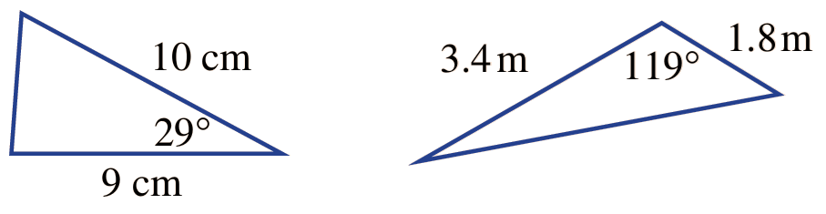
Find the area of this triangle, to 1 d.p.
$$A=\frac{1}{2}ab\sin{C} \\ =\frac{1}{2}\left(3.4\right)\left(1.8\right)\sin{119°} \\ ≈2.7 {km}^{2}$$

- Guided Practice
Find the area of these triangles, to 1 d.p.
21.8 cm² | 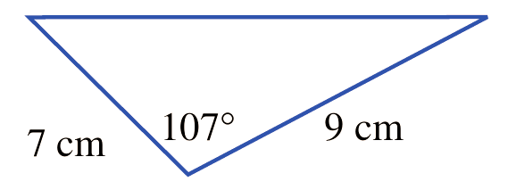  30.1 cm²
Find the side length, to 2 d.p., given the area.
- $A=70$ cm²  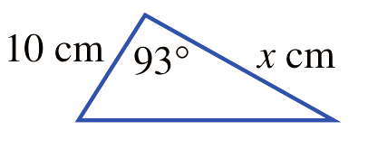  14.02 cm | - $A=37$ cm²  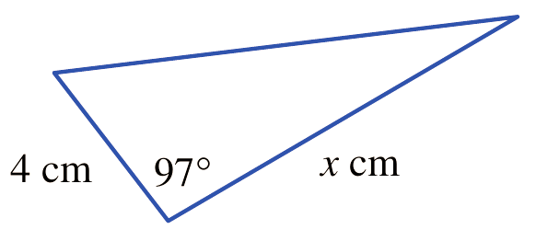  18.64 cm

Selecting an Appropriate Method and Mixed Problems

- Methods for Non-Right-Angled Triangles
For non-right-angled triangles, determine what is involved in the question:
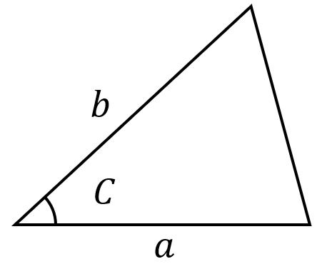  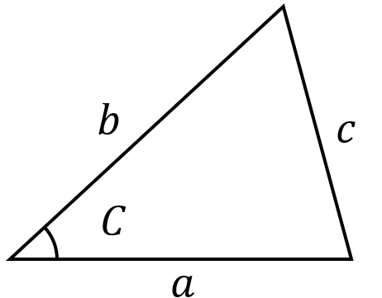  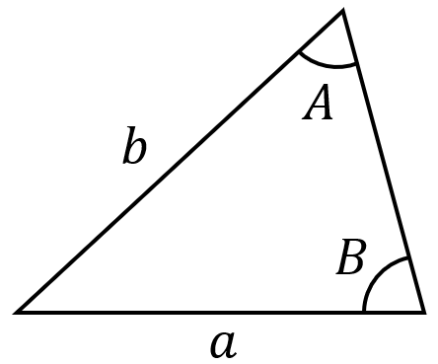  2 sides 2 angles  Sine Rule  $$\frac{\sin{A}}{a}=\frac{\sin{B}}{B}$$  $$\frac{a}{\sin{A}}=\frac{b}{\sin{B}}$$ | 3 sides 1 angle  Cosine Rule  $$c^{2}=a^{2}+b^{2}-2ab\cos{C} \\ \cos{C}=\frac{a^{2}+b^{2}-c^{2}}{2ab}$$ | Area  SAS Area Rule  $$A=\frac{1}{2}ab\sin{C}$$

- Identify which rule you would use to find the unknown
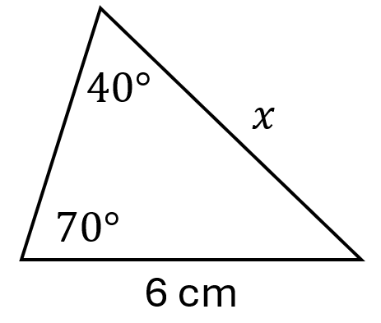  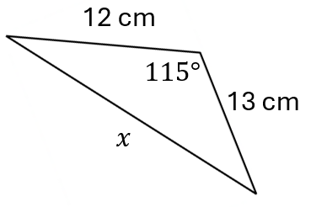 | 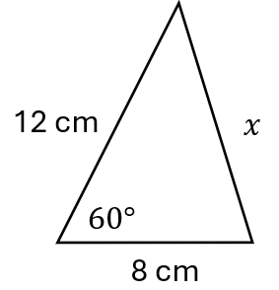 |  | 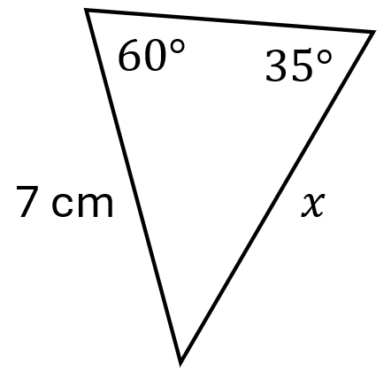
 |  | 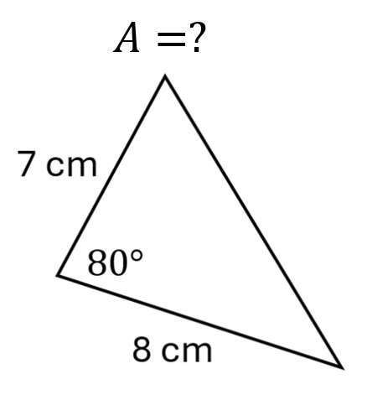 | 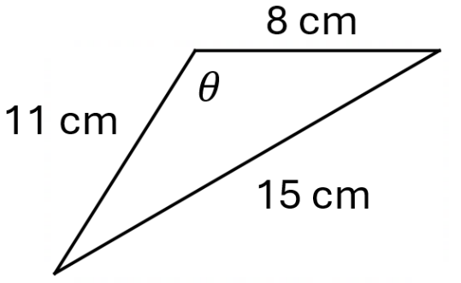  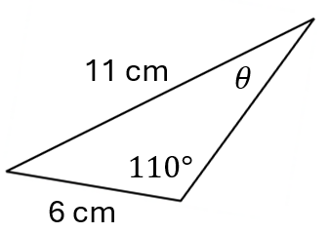  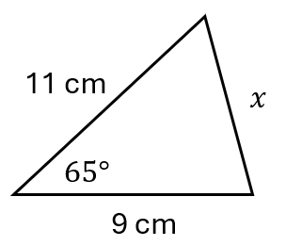
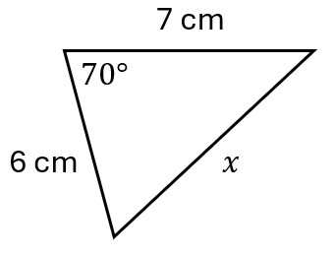 | 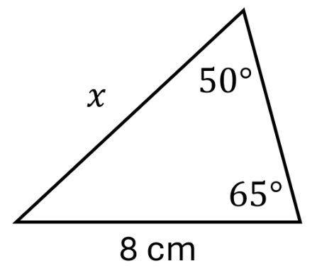 | 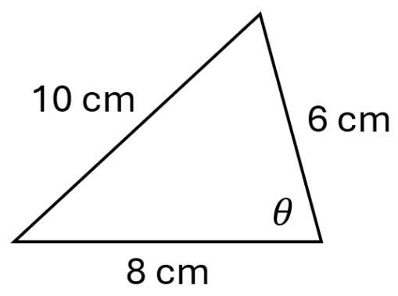 | 